CSCI 440 – Applied Software Project Development

Check Me out

Version *<0.1>*

*2/1/2018*

**Prepared by Thomas Lawhon, Daniel Calvo, Colleen Coggins, and Wylder Barrows**

**TABLE OF CONTENTS**

1 Problem Statement 3

1.1 Background & Environment 3

1.2 Benefits 3

1.3 Capabalities 3

2 Project Management Plan 3

2.1 Top-level design 3

2.2 Work Breakdown Structure 3

2.3 Skill Matrix 3

2.4 Roles 3

2.5 Project Schedule 3

3 Constraints And Risks 4

3.1 Constraints 4

3.2 Risks 4

4 User Stories 4

5 <Project Name> Details 4

6 Team Progress 4

6.1 Team Communication 4

6.1.1 Planning 4

6.2 Peer Evaluation 4

6.2.1 Planning 4

APPENDIX A: REFERENCES 5

APPENDIX B: KEY TERMS 6

# Problem Statement

## Background & Environment

## For this project we decided to create an eCommerce website for online shopping. We chose this type of application, because our group had a lot of interest in the subject of web design. Our project aims to provide the user with the best possible shopping experience compared to other online shopping sites. We plan to complete this by providing the user with suggested products based of popularity, recent purchases, and provide them with tools that make currency conversion easy. Shopping online has become one of the major ways that customers buy items. Learning how to create an eCommerce web site is important, because it is seen as the future of shopping. Check Me Out is meant to be used by a wide variety of users ranging from corporations to your average consumer. Users can access our site from all popular web browsers and most mobile devices (targeting android browsers an iOS browsers). We plan to have some focus on mobile support for our site, but.Check Me Out will be mainly focused on desktop/laptop base browsers. Our site should have little to no downtime, given the nature of the web technologies we plan to use (HTML, PHP, MySQL, ect.) Check Me Out can be updated on the fly. This includes adding pages and items. This allows the users to be able to access the site at all times from their chosen devices. Check Me Out can be used anywhere a user has access to the internet.

## Benefits

The main benefit to our system will increase in productivity for the eStore. With our easy to use system customers will be using our system to checkout instead of the long checkout lines at traditional stores. Customers also get important information on items, recommendations and conversions.

Our system also brings with it the benefits of:

* Ease of use – customers will be able to quickly add items to their cart and instantly purchase single items.
* Automation – More orders can be processed than at a traditional store, because eCommerce is more scalable
* Organization – A general increase of eStore organization centralized around our system.

## Capabalities

Check me out will include the following capabilities:

* Display Items in purchasable format to users
* Create and manage user accounts
* Store user items in shopping cart
* Show brief history of customer’s purchases
* Suggest products based on customer’s purchase history and popular items
* Price comparison from rival sites
* Location based currency conversion through user selected options

# Project Management Plan

## Top-level design

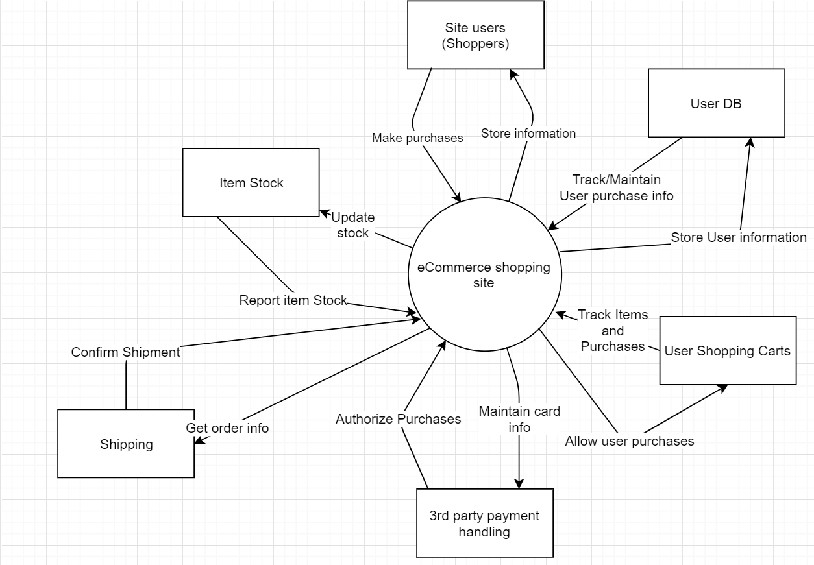

Figure 1. Context Diagram

This is our Context Diagram. Here you can see our relationships between each of the parts of our application and how they somewhat interact with each other. Ecommerce sites have many moving parts. Most of these parts work together to complete a single order. For example, when a shopper adds an item to their cart and checks out the item you see that the user database, item stock, user cart, 3rd party handling and shipping are all involved.

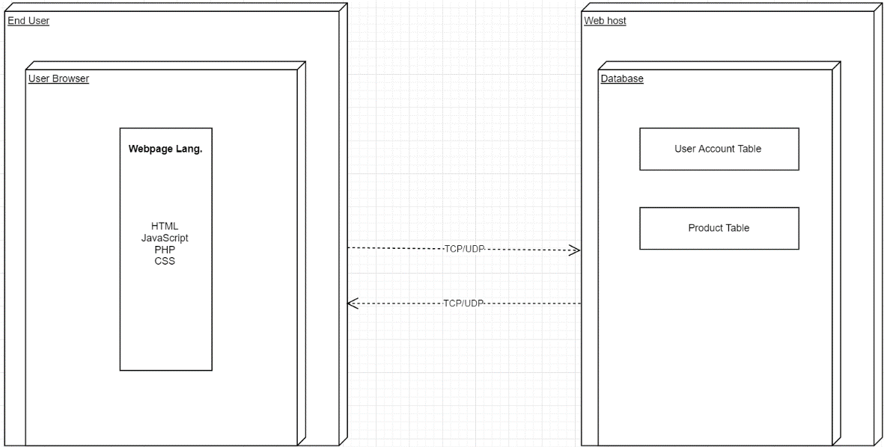

Figure 2. Deployment Diagram

Our deployment diagram is really basic, mostly because we do not have to deal with setting up servers ourselves. We plan to use a webhost to host our site and our database. The interactions are pretty simple between the webhost and the end user. The end users browser would send a page request to the server and then the server would send the information to the browser. This process sends PHP scripts to the user that queries SQL items for the user. The user pages are mostly planned to contain basic web technologies such as HTML, CSS, and JavaScript. For our user accounts we will have a table that stores information about the user.

## Work Breakdown Structure

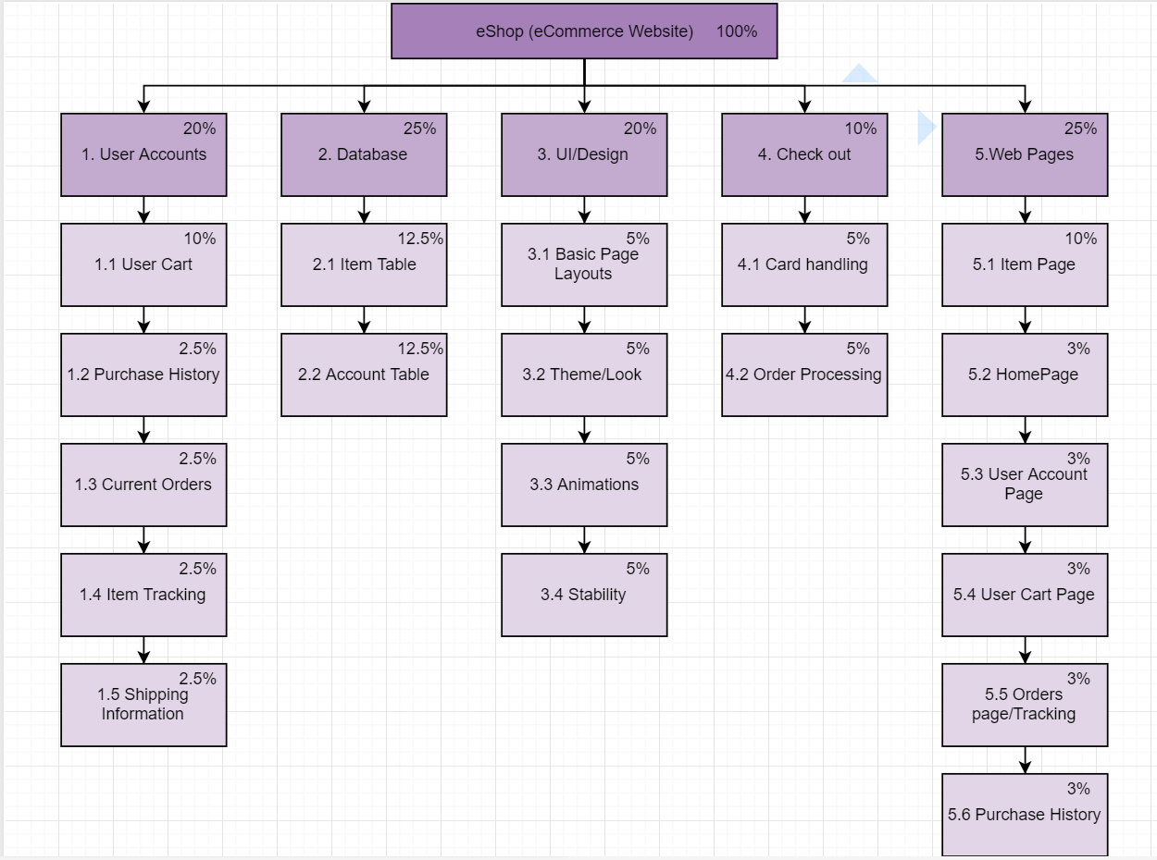

Figure 3. WBS

This is our preliminary WBS. All of the main categories are there. The only changes that we would have to make would go below the main categories. You can see that each category has a total percentage with each sub category showing a smaller percentage. These percentages difficult to produce originally. We decided to give weighted percentages based off what we considered to be difficult. We concluded that difficulty and importance are directly correlated with time consumption.

## Skill Matrix

|  |  |  |  |  |  |
| --- | --- | --- | --- | --- | --- |
| Programming Skills | Wylder Barrows | Thomas Lawhon | Daniel Calvo | Colleen Coggins |  |
| JavaScript | 2 | 3 | 3 | 2 |  |
| HTML | 5 | 5 | 5 | 5 |  |
| CSS | 5 | 5 | 5 | 5 |  |
| PHP | 3 | 3 | 2 | 2 |  |
| MySQL | 3 | 2 | 3 | 3 |  |

(These skill values are based off a scale of 1 to 5. One being not interested and five being interested.)

## Roles

| **Name** | **Project Role** | **Project Responsibilities** |
| --- | --- | --- |
| Wylder Barrows | Project Manager/Programmer | Manage project, Keep with deadlines, help with programming |
| Thomas Lawhon | Programmer | Program the main structures of the web pages |
| Colleen Coggins | Document Management/Program tester | Proof read, improve, and maintain documentation of the project, while providing user feedback and testing. |
| Daniel Calvo | Programmer/DB admin | Assist in the creation of web pages, scripts, and the maintainer of database information. |

## Project Schedule

Figure 4. Grantt Chart

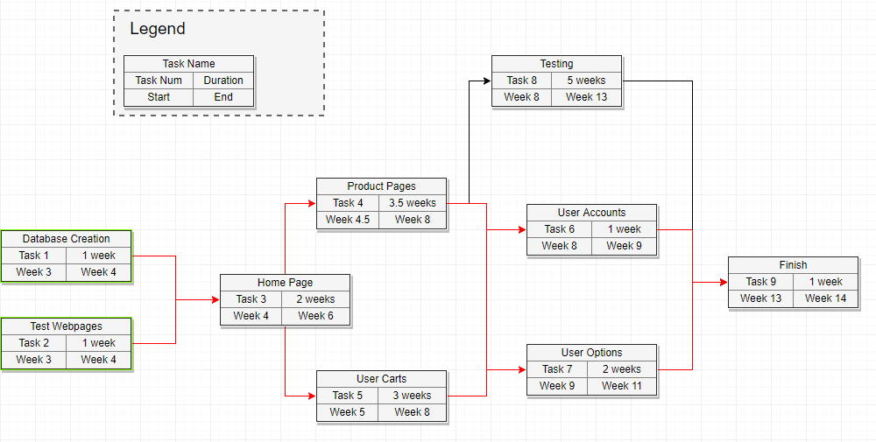

Figure 5. Pert chart

# Constraints And Risks

## Constraints

1. Due to the limited amount of knowledge with the collection of web based programming technologies required for this project, it will most likely mean that extended work time is required.
2. Throughout the production and final phases of this project, it is required for us to use a web hosting service. Proper monetary needs will be of concern before production begins.
3. Research will be limited to the internet due to the lack of face-to-face resources.

## Risks

1. *LOW* - Tech Failure: Each member owns multiple laptops/computers. The chances for limited tech resources and failures will be unlikely.
2. *LOW* - Insufficient Funds: Web hosting prices are not extreme and very affordable. There are minimal chances for the inability to pay for subscription.
3. *MEDIUM* - Missing Deadline: Time constraints will be a large issue due to our lack of knowledge with programming and integrating multiple functionalities into a web application.

*HIGH* - Immense Research Time: Research will be long and dense due to our inexperience. It is best to expect that the learning curve will be high.

# User Stories

Features:

* Shopping Carts
* Item Pages
* Home Page
* User Accounts
* User Information
* Product Recommendations
* Currency Conversion
* Order History

The user stories of the Check Me Out are as follows:

* As a user, I want to have a central location for me to find products (home page) so that on line shopping is easier.
* As a user, I want account information saved so that return shopping is easier.
* As a user, I want to be able to see my previous orders so that I can track shipping or cancel orders.
* As a user, I want recommendations for popular products so that I can see what other users are purchasing.
* As a user, I want a shopping cart to store my online items.
* As a user, I want to be able to administrate my shopping cart so that I can change items and amounts.
* As a user, I want secure check out, so that my user information is safe.
* As a user, I want to see options for other currencies so that purchasing in other countries is easier.

# <Project Name> Details

*[In later deliverables.]*

# Team Progress

## Team Communication

### Planning

We are currently using discord to communicate and by default there is not ability to log conversations (they claim this is for security). Our project manager has found a solution to this problem, but it is not retroactive. We will include, from here on out, text of all our logs in the future.

We will be making a github for week 3/4 as we start on our project integration.

Responsibilities (we all have the responsibility to code on this project)

* Wylder Barrows – Project manager/In charge of communication
* Thomas Lawhon – In charge of Git Hub management
* Daniel Calvo – In charge of page testing and DB admin
* Colleen Coggins – In charge of document proof reading and page testing

## Peer Evaluation

### Planning

Wylder Barrows – I enjoy working with this group. Our communication has been a decent, but this is due to the semester beginning, and getting acclimated to the new semester. I dropped the ball this week and forgot about assignment 1 being due, so I was late to assigning sections. I plan to be more on top of things as we move forward. We haven’t started any programming yet, so I cannot asses that aspect yet. This coming week we will all be on the same page, and we will be coding our datebase and our testing pages.

Daniel: The group is working well together. Everyone is keeping up with clear and instant communication.

Thomas: I feel that our group communicated very well and everyone completed their assigned work properly and on time.

Colleen: I am fine with everything and our communication

APPENDIX A: REFERENCES

[Insert the name, description, and physical location of any documents referenced in this document. Add rows to the table as necessary.]

The following table summarizes the documents referenced in this document.

|  |  |  |
| --- | --- | --- |
| **Document Name and Version** | **Description** | **Location** |
| *<Document Name >* | *[Provide description of the document]* | *<URL or Network path where document is located>* |

APPENDIX B: KEY TERMS

*[Insert terms and definitions used in this document. Add rows to the table as necessary.]*

The following table provides definitions for terms relevant to this document.

|  |  |
| --- | --- |
| **Term** | **Definition** |
| *[Insert Term]* | *[Provide definition of the term used in this document.]* |
| *[Insert Term]* | *[Provide definition of the term used in this document.]* |
| *[Insert Term]* | *[Provide definition of the term used in this document.]* |